The Inside Outline
Workbook
by Jennie Nash

WHAT IS THE INSIDE OUTLINE?

AN OUTLINE

It’s a short and flexible outline of the major scenes of a novel.

A TIMELINE

It’s a timeline that captures the chronology of the story.

A MARRIAGE OF PLOT AND POINT

It’s a way to bring together the two most important parts of the story in one place.

A CONTAINER

It’s an efficient way to capture and hold the whole story as you write forward, make
changes, and revise.

A CAUSE-AND-EFFECT TRAJECTORY

It’s an illustration of the engine that propels a novel from start to finish.

WHY DOES IT WORK?

IT LETS YOU SEE THE WHOLE

You can stand back and see the sweep of the whole story, which is a critical perspective to success.

IT FORCES YOU TO FOCUS ON WHAT IS MOST IMPORTANT

It never lets you forget that every action has to have a point and purpose. You can’t
write a scene without knowing the point.

IT MEASURES NARRATIVE DRIVE

It shows you how one scene drives to the next and how one action causes the next,
and allows you to measure where your story may have mistakes or holes.

IT GIVES YOU PERMISSION TO INNOVATE

You can easily cut, add, or move scenes to see how they work in various locations.
There is no risk to innovating on a three-page document.

IT SHOWS OTHERS WHAT YOU ARE THINKING

It’s a powerful way to get quick, insightful feedback on your story from critique partners
or your book coach.

IT GIVES YOU AN ADVANTAGE WHEN IT’S TIME TO SUMMARIZE

An Inside Outline is an ideal start to a synopsis (needed for agents) or a book summary
(needed for independent publishing).

HOW IT LOOKS

PLOT — what happens
POINT — why it matters to the protagonist

BECAUSE OF THAT…

PLOT— what happens
POINT — why it matters to the protagonist

And so on…

EXAMPLE

Thanks to KJ Dell’Antonia for sharing her WIP

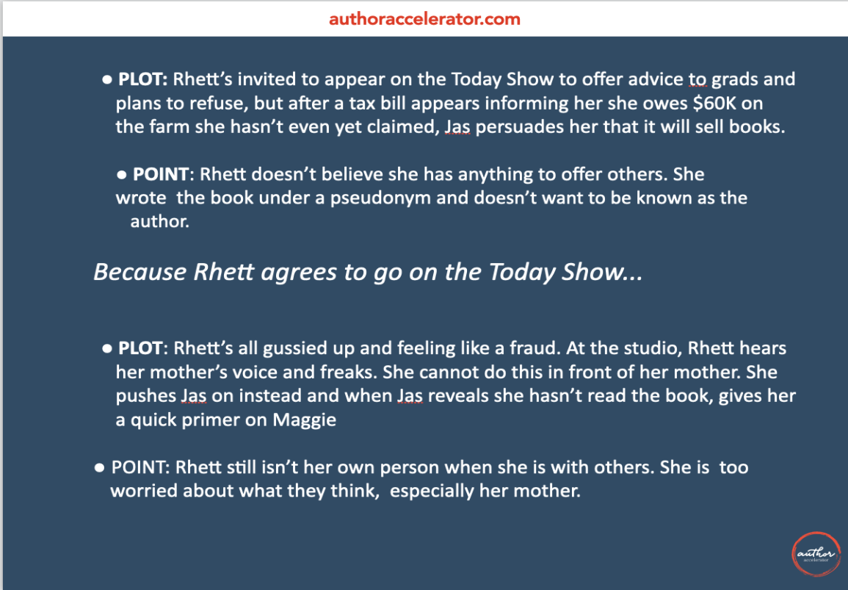

WHAT TO INCLUDE

Focus on the major events of your novel — the high and low points that define the shape of the story. This graph of Cinderella, from Kurt Vonnegut’s story graphing YouTube video, gives you a sense of what I mean. Plan to include somewhere between 13 to 22 events in total.

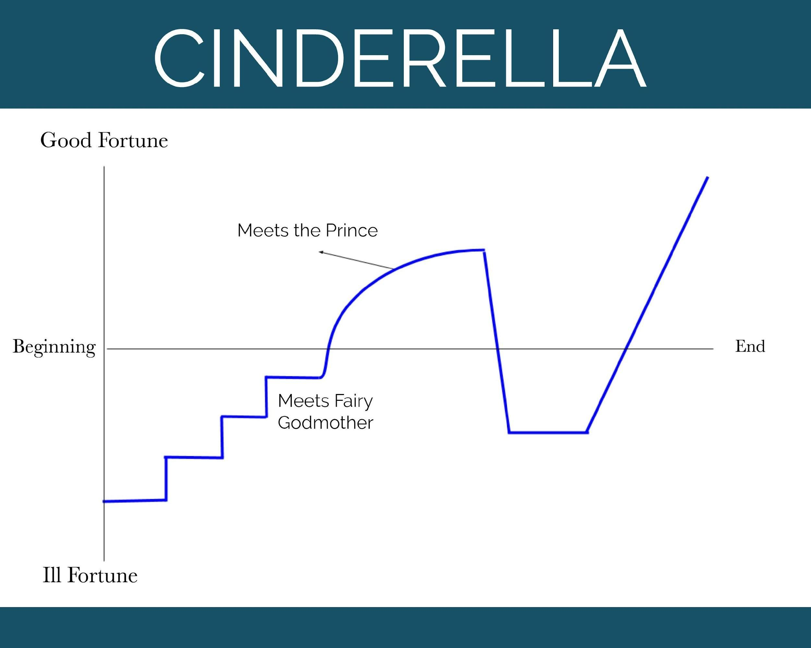

For each event you chose to include in your Inside Outline, add the point. Ask yourself:

  - What happens in this scene or scenes?
  - What does it add to the story?
  - Why does this scene have to happen?
  - Why does it have to happen now (i.e., why does it have to happen after the last scene and before the next one)?
  - What meaning does the protagonist make from this scene? And how does that propel them to take the next action they take?

FOLLOW THE RULES

The Inside Outline works best if you follow these rules:

- No more than three pages because the power comes from being CONCISE. Don’t cheat by reducing the font or squeezing the line spacing.
- No more than three lines per bullet point.
- Each scene must cause the next scene to happen. Think “because of that, the next thing happened” rather than “and then this happened, and then this happened, and then this happened.”

CHECK YOUR WORK WITH THE TEN-POINT INSIDE

OUTLINE CHECKLIST

Now stand back and look at the sweep of your story. Use the Ten-Point Inside Outline Checklist to check your work. Go to jennienash.com/blueprint to download a
copy.

AND THEN WHAT?

After you develop a 3-page version that is watertight, you can increase the number of events and the number of pages in your Inside Outline. In this way, the Inside Outline can become a living, breathing outline that captures your entire story as you write forward.

An Inside Outline that includes every scene of a novel might be 8 or 9 pages long. It’s a fantastic took for planning a revision of a finished manuscript.

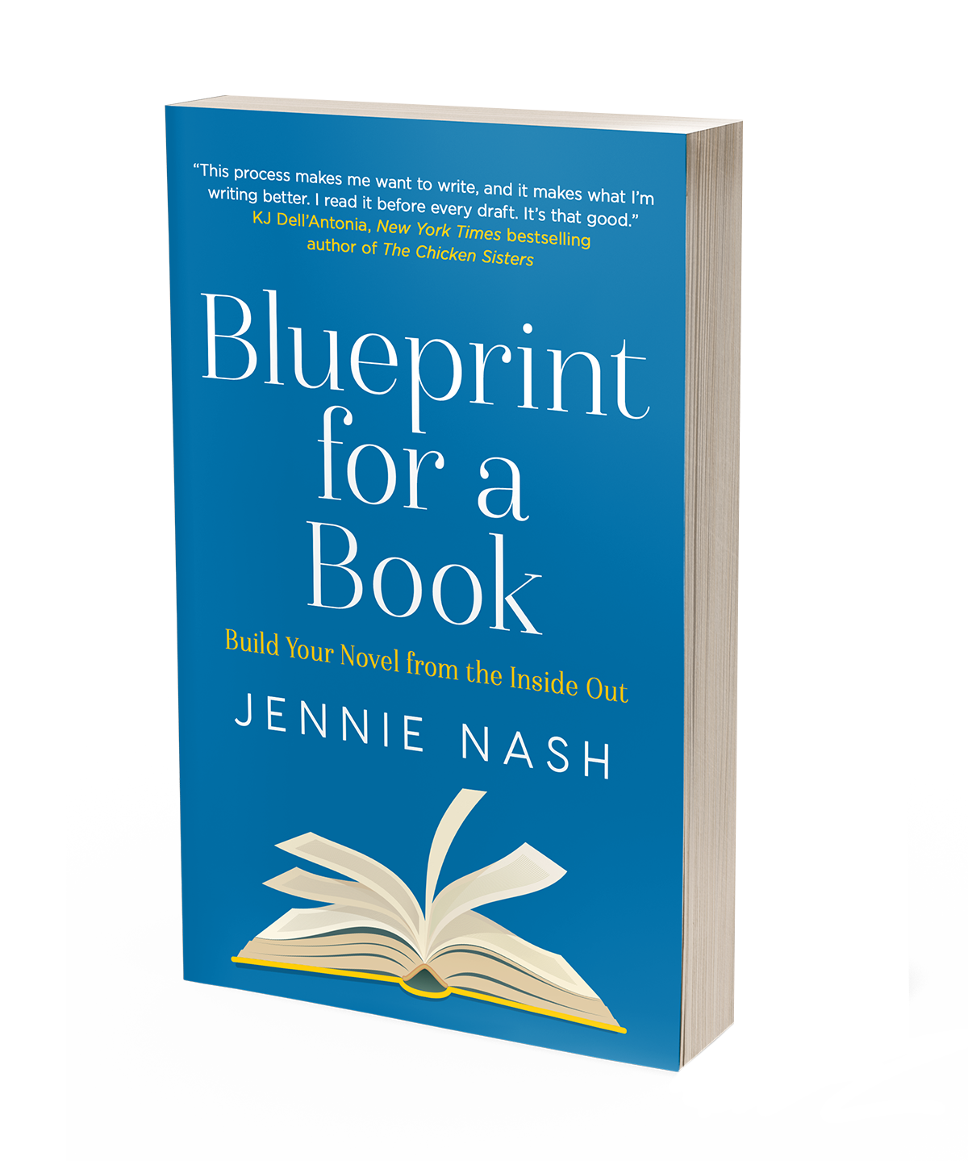

LEARN MORE

How to write a n ovel in the most efficient way by tackling the hardest part before you start to write, from top book coach Jennie Nash
"This process makes me want to write, and it makes what I'm writing better. I read it before every draft. It's that good." -KJ Dell'Antonia, New York Times bestselling author of The Chicken Sisters
Whether you’re writing your first novel or your tenth, there is a temptation to pin it to the page before it disappears. It’s such a brilliant idea and you can see the whole thing shimmering in your mind, just out of reach. Maybe you do some work on character development and plotting, but you’re a racehorse at the gate, ready to run, ready to write.
This book is an argument to stop and define the foundational elements of your story before you keep writing – which means understanding your motivation as a writer, considering your reader’s expectations, and making sure your story has a solid structure that will hold up inside and out from beginning to end. This clarity is what gives a novel its power and a writer their confidence.

Purchase at amazon
Visit jennienash.com/blueprint for more resources

